# Customer Insights Advanced Training

Infrastructure Provisioning

Contents

Step 1 – Office 365 Trial 3

Step 2 – Customer Insights Trial 7

Step 3 – Install Visual Studio Community 10

## Approximate Time to Complete – 30 mins

# Step 1 – Office 365 Trial

The first step in the process is to create an Office 365 tenant for your user accounts. Open an “in private” browser window and navigate to <https://aka.ms/appinadayo365signup>. Fill in your email address and click **Next**

On the next screen, you will want to click on the **Create a new account instead**

You are now able to fill in information about yourself, then click **Next**

Now you will be asked for a phone number to text or call with a verification code.

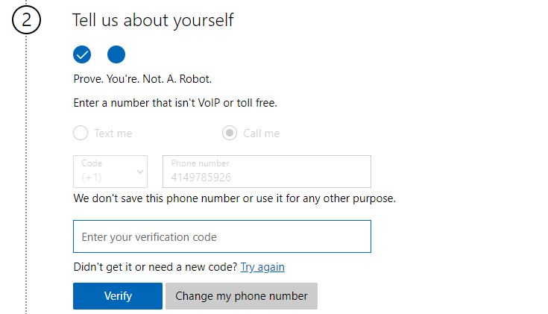

After entering the verification code and continuing you will next be able to choose your business identity. You will need to provide an admin user account. The Username will be the admin account, the domain will be the domain address you will use for your account. Enter a password into both fields. Then click **Next**.

Once everything completes you will get a page like this where you can click **Get Started** if you’d like to setup mail or install office apps. For the purposes of this training you are done at this point and do not need to do either of those things.

# Step 2 – Customer Insights Trial

Now that we have setup our Admin user, Power Apps license and Dynamics we are ready to request our Trial of Customer Insights. Open a new “in private” browser instance and navigate to <https://aka.ms/tryci>.

On the page enter the email for your admin account created in Step 1, like this and then click **Next**.

If prompted click **Sign In**

Next click **Get Started**

Now confirm your details and click **Get Started**

A new tab will open. Select your Country/Region and click **Continue.**

Finally, click the **Audience insights** option for your focus.

For the Choose your Business select **Invidiual consumers (B-to-C)**

It will do a few screen refreshes and then ask you to login again, use the same user login you used on the first screen and the click accept on the permissions pop-up. The final steps take place in Customer Insights.

Next click the **Start trial** button in the top left corner of the screen.

Next you will create the environment. We suggest you name it **CIADWorkshop**. Select **Individual consumers (B-toC)** for the Choose your business dropdown. Select a region that is near your location. Once you enter the name and select the region you can click **Review and Finish**.

Finally, you will see the screen below and click **Create**.

If all has gone as it should you should now be seeing the **Almost done…** screen.

## 

## Step 3 – Install Visual Studio Community

For the extensibility lab we will use Visual Studio to create a small application. You will need to install the Community edition of Visual Studio to do this lab.

Navigate to <https://docs.microsoft.com/en-us/visualstudio/releases/2019/release-notes> and click on the **Download Community 2019**

Once it downloads in your browser **Run** the executable to install the package.